Q.1 What is intelligence?

Ans.

* Natural and artificial intelligence:
* The word “intelligence” comes from the Latin “intelligo” which means “I understand”.
* The basic meaning of intelligence is the ability to understand or to get it means so we react.
* Intelligence is the computational part of the natural ability to achieve desired goals in the world.
* The ability to respond quickly, according to the situation using natural intelligence.
* The ability to respond quickly, to make out of ambiguous, contradictory and incomplete information, by recognizing the relative importance of the different elements of a situation, and to find similarities in dissimilar situations and vice versa comes from the natural intelligence.

Q.2 What is Artificial intelligence?

Ans.

* AI is the branch of the computer science which deals in making/doing things by machine/computer for which at the moment human are better.
* AI is the branch of the computer science concerned with making computers behave like humans.
* In other words, it’s a symbol processing and non-algorithmic approach for problem slowing.
* AI depends on heuristics.
* Heuristic means rule of thumb which does not give guarantee of success.
* AI is the branch of computer science that attempts to solve problems by mimicking human thought processes using heuristics and the symbolic and nonalgorithmic approach.
* AI involves:
* Studying the thought process of humans.
* Deals with representing those processes via machines.
* AI implements leads to:
* Intelligence becomes permanent.
* Speedy problem solving.
* Ease of duplication.
* Less expensive.
* Ease of documentation etc.

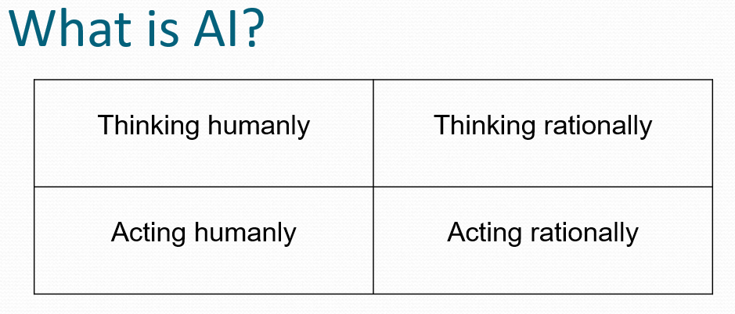

Q.4 AI Domains?

Ans.

* Some of ai domains area of ai are identify:

1. Mundane Tasks
2. Perception

* Vision
* Speech

1. Natural language

* Understanding
* Generation
* translation

1. Common-sense reasoning
2. Robot control
3. Formal Tasks
4. Games

* Chess
* Backgammon
* Checkers
* Go

1. Mathematics

* Geometry
* Logic
* Integral calculus
* Proving properties of programs

1. Experts tasks
2. Engineering

* Design
* Fault finding
* Manufacturing planning

1. Scientific analysis
2. Financial analysis

Q.4 Criteria of ai?

Ans.

* Before traying to solve specific AI problem it is important to analyse following criteria
* What are over underline assumptions about inelegance.
* What kind of techniques will be use full for solving AI problem?
* What label of detail we are try to model human intelligence?
* How we will know we have succeeded in building intelligent program.

Q.5 AI Technique?

Ans.

* To understand ai technique its important to know about knowledge because ai require knowledge and it has some less desirable characteristic as follows:
* Its Volume less
* Hard to characterize accurately
* Its Constantly changing
* Differs from data by being organized in aa way that corresponds to way it will be used.
* AI technique is a method that exploits knowledge that should be represented in such a way that:
* The Knowledge captures generalization
* It can be understood by people who must provide it
* It can be easily modified to correct errors and deflect changes.
* It can be used in variety of situations if it is not totally equrate.
* It should reduce its own bulk of knowledge by narrowing down possibilities.
* Intelligence requires Knowledge
* Measuring the degree of intelligence

- These tests are applied to measure the degree of the intelligence and level of machine understanding achieved.

Q.5 Testing the intelligence?

Ans.

1. Turing test by alan turing in 1950

* Purposed a test with following method:
* A Turing Test is a method of inquiry in artificial intelligence (AI) for determining whether or not a computer is capable of thinking like a human being.
* The test is named after Alan Turing, the founder of the Turning Test and an English computer scientist, cryptanalyst, mathematician and theoretical biologist.
* Turing proposed that a computer can be said to possess artificial intelligence if it can mimic human responses under specific conditions.
* What is the turing test:
* The original Turing Test requires three terminals, each of which is physically separated from the other two.
* One terminal is operated by a computer, while the other two are operated by humans.
* During the test, one of the human’s functions as the questioner, while the second human and the computer function as respondents.
* The questioner interrogates the respondents within a specific subject area, using a specified format and context.
* After a preset length of time or number of questions, the questioner is then asked to decide which respondent was human and which was a computer.
* The test is repeated many times. If the questioner makes the correct determination in half of the test runs or less, the computer is considered to have artificial intelligence because the questioner regards it as "just as human" as the human respondent.

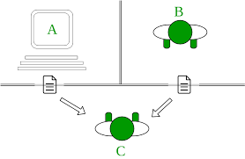

1. Chinese room experiment by john Searle

* The Purpose:
* John Searle, an American philosopher, presented the Chinese problem, directed at the AI researchers.
* The Chinese Room conundrum argues that a computer cannot have a mind of its own and attaining consciousness is an impossible task for these machines.
* They can be programmed to mimic the activities of a conscious human being but they can’t have an understanding of what they are simulating on their own.
* “A human mind has meaningful thoughts, feelings, and mental contents generally.
* Formal symbols by themselves can never be enough for mental contents, because the symbols, by definition, have no meaning,” said Searle when questioned about his argument.

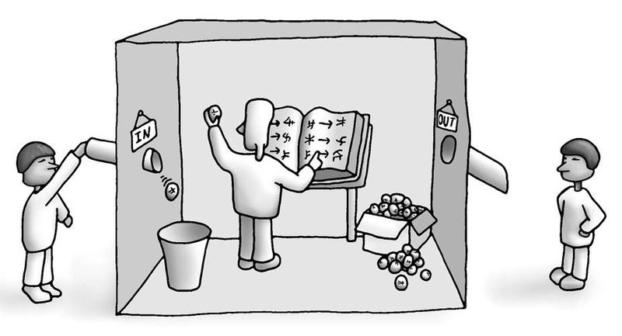

* What Is the Chinese Room Conundrum?
* Searle explained the concept eloquently by drawing an analogy using Mandarin.
* The definition hinges on the thin line between actually having a mind and simulating a mind.
* Searle’s thought experiment goes like this:
* Suppose a closed room has a non-Chinese speaker with a list of Mandarin characters and an instruction book.
* This book explains in detail the rules according to which the strings (sequences) of characters may be formed — but without giving the meaning of the characters.
* Suppose now that we pass to this man through a hole in the wall a sequence of Mandarin characters which he is to complete by following the rules he has learned.
* We may call the sequence passed to him from the outside a “question” and the completion an “answer.”
* Now, this non-Chinese speaker masters this sequencing game so much that even a native Chinese person will not be able to spot any difference in the answers given by this man in an enclosed room.
* But the fact remains that not only is he not Chinese, but he does not even understand Chinese, far less think in it.
* Now, the argument goes on, a machine, even a Turing machine, is just like this man, in that it does nothing more than follow the rules given in an instruction book (the program).
* It does not understand the meaning of the questions given to it nor its own answers, and thus cannot be said to be thinking.
* Making a case for Searle, if we accept that a book has no mind of its own, we cannot then endow a computer with intelligence and remain consistent.
* The Following Questions
* How can one verify that this man in the room is thinking in English and not in Chinese? Searle’s experiment builds on the assumption that this fictitious man indeed thinks in English and then uses the extra information from the hole in the wall and masters those Chinese sequences.
* But Turing’s idea was that no such assumptions should be made and that comprehension or intelligence should be judged in an objective manner.
* The whole point of Searle’s experiment is to make a non-Chinese man simulate a native Chinese speaker in such a way that there wouldn’t be any distinction between these two individuals.
* If we ask the computer in our language if it understands us, it will say that it does, since it is imitating a clever student. This corresponds to talking to the man in the closed room in Chinese, and we cannot communicate with a computer in a way that would correspond to our talking to the man in English.
* The texts or the set of instructions cannot be dissociated from the man in the experiment because this instruction, in turn, is prepared by some native Chinese person.
* So, when the Chinese expert on the other end of the room is verifying the answers, he actually is communicating with another mind which thinks in Chinese.
* So, when a computer responds to some tricky questions by a human, it can be concluded, in accordance with Searle, that we are communicating with the programmer, the person who gave the computer, a certain set of instructions to perform.
* Outlook
* Any theory that says minds are computer programs, is best understood as perhaps the last gasp of the dualist tradition that attempts to deny the biological character of mental phenomena.
* Searle’s speculation in spite of its inadequacies tests the boundaries of AI and makes an attempt to dispel the weak ideas of pseudo-intellectual futurists.
* Searle in negating the capabilities of AI, has, in fact, exposed the blind spots in our pursuit of General AI and made it more robust.

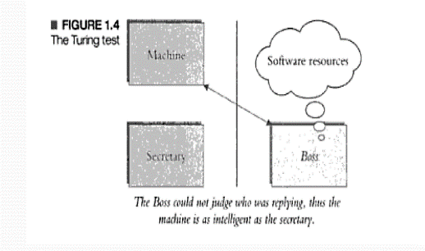 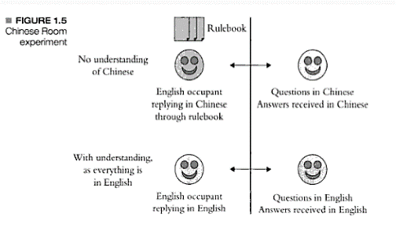

Q.6 Explain Problems, problem space &

Ans.

* **Problem**: to build a system to solve a particular problem, we need to do four things:

1. Define the problem precisely.
2. Analyze the problem.
3. Isolate and represent the task knowledge that is necessary to solve the problem.
4. Choose the best problem-solving technique and apply it to the particular problem.

* Water jug problem:
* **Consider the following problem:** In the water jug problem in Artificial Intelligence, we are provided with two jugs one having the capacity to hold 3 gallons of water and the other has the capacity to hold 4 gallons of water.
* There is no other measuring equipment available and the jugs also do not have any kind of marking on them.
* So, the agent’s task here is to fill the 4-gallon jug with 2 gallons of water by using only these two jugs and no other material. Initially, both our jugs are empty.
* So, to solve this problem, following set of rules were proposed

How can you get exactly 2 gallons of water in the 4-gallon jug?

* **State Representation and Initial State**: we will represent a state of the problem as a tuple (x, y) where x represents the amount of water in the 4-gallon jug and y represents the amount of water in the 3-gallon jug.
* Note 0 ≤ x ≤ 4, and 0 ≤ y ≤ 3.
* Our initial state: (0,0)

Goal Predicate – state = (2,y) where 0 ≤ y ≤ 3.